Our first example involves calculating the gravitational force between a point mass M and an extended rod of mass m, length L, and mass per unit length,.

To begin, divide the rod into a finite (countable) number of segments of mass each located at a distance x from M.

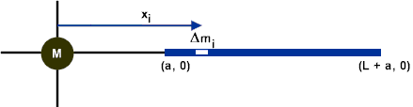

Each of these segments will contribute a gravitational force of attraction.

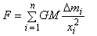

If we take the limit as approaches zero, then our expression for F becomes

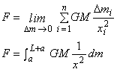

Before we can integrate we must express in terms of .

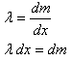

Substituting and integrating gives us

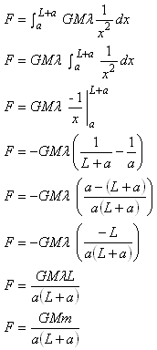

where
.

